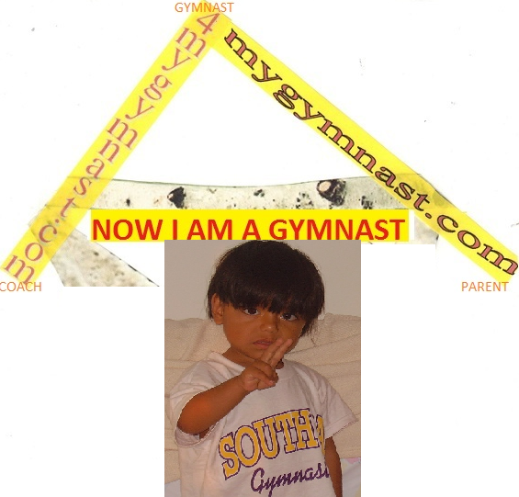
By: Marco & Pintack Gualotuña: This book was created by http://4gymnast.com/ in cooperation of rhythmic gymnastics, gymnastics, cheer, ballet and other related literature, with Computers in Education. Edited by Pintack and Marco Gualotuňa. All information on this page and the subsequent pages is copyrighted by Computers in Education; the data may not be copied, not modified, or taken without the express written permission of that party. Images contained herein may or may not be copyrights of the aforementioned company. In the case of shared copyright, no attempt to change these images is implied nor intended to alter them. Any questions should be mailed to m2educate@hotmail.com or call @ 310-425-4292 or 310-327-5383.
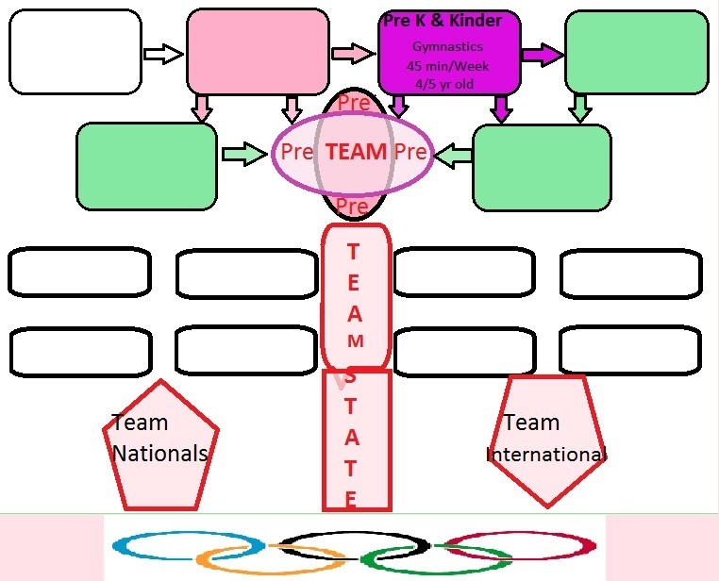
A1. A gymnast in his making a new move in kinder gym for children 4, 5, 6
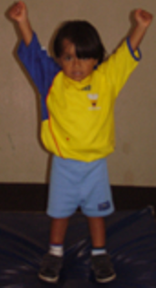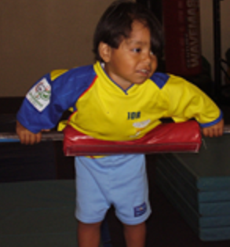
B1. Smiling on new levels in gymnastics
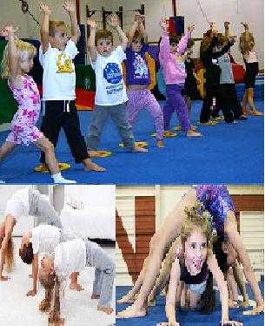
A1: Gymnastics for my monkey
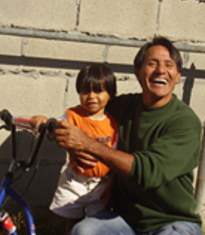
AA. My son to whom I love! 10.0
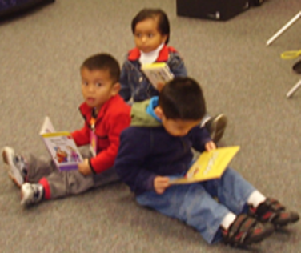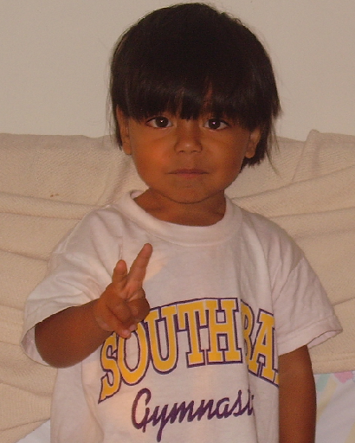

B1. Gymnast simple moves to warm up
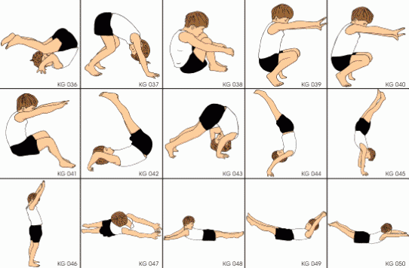
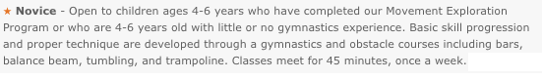
A1. The best team in gymnastics A+
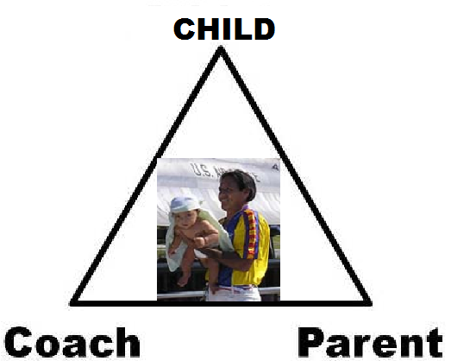
Gymnastics is playing with family and friends!
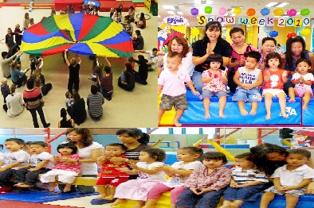
B1. Equilibrium and balance in splits move C with score 5.0
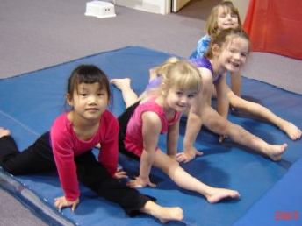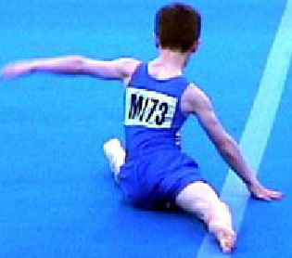
C2. 3 Basic skills in gymnastics
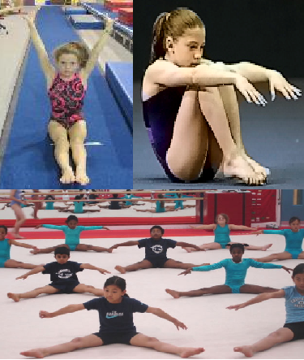

D: 6 Basic moves for children
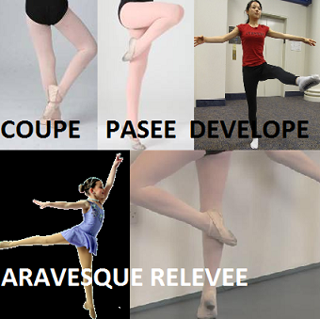
A1. Everyone’s feet up on the wall perfect skill to promote hands stands
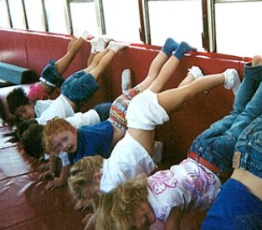
B1. Now strength exercise moves done on the floor are done on the volt, beam, and bars
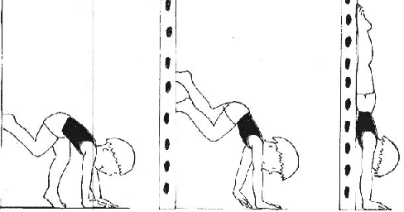
B1. Bridge up boys and hold for 3”
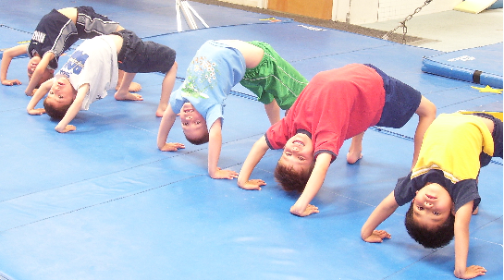
C1. Is this gymnastics? Every one upside down
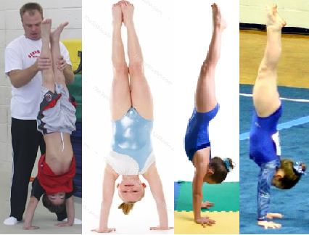
D1. My hands stand in the gym, on the floor with my friends
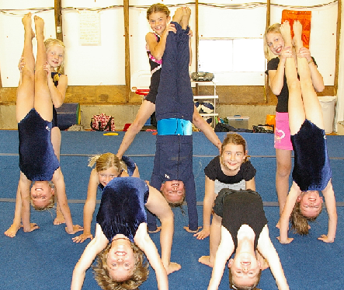
D2. Many hands stand for 8.55
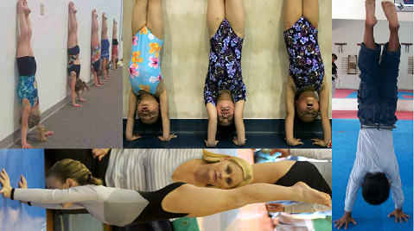
A1. Evaluations on hands stand 9.1
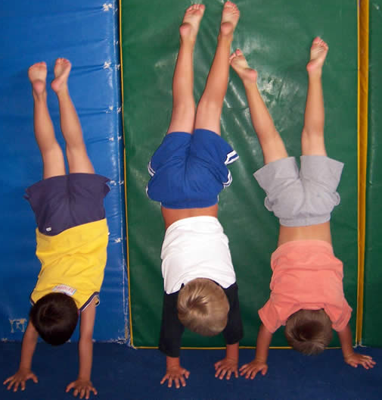
B1. Pintack my son’s hands stand in his effort is his perfection 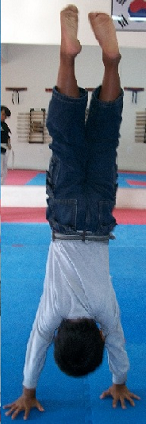
A1. Help stretch for a bridge good skill for advance moves 9.1
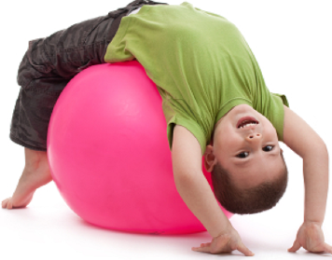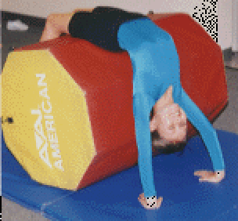

B1. Safety a nice move that leads into good practices 9.1
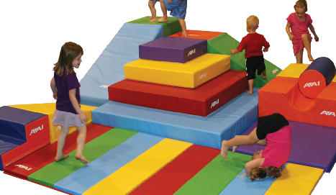
C1. Back hands springs over helper’s difficulty 9.1
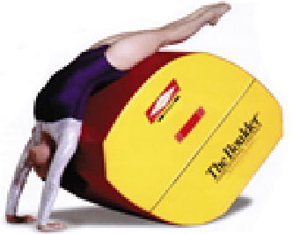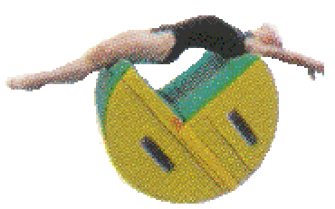
C1. Floor cheese mats important equipment for beginning gymnast or kinder gym
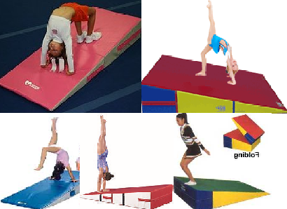

These six skills done on the floor are taken to bars, volt, beam, parallels, and palm horse
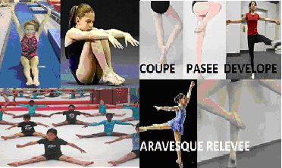
We are the team
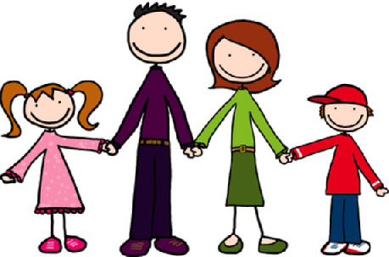
A1: Our multitude of duties, but to teach our children is the most important one!
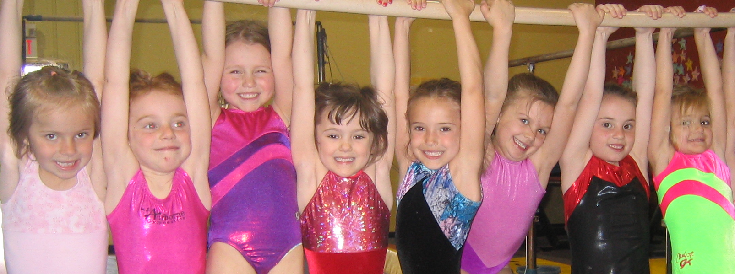
A1. These are my kids!
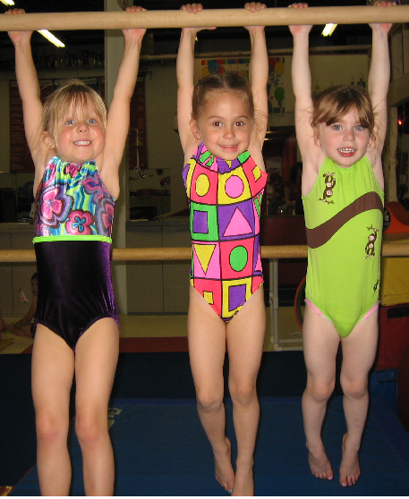
C1. Equilibrium in gymnastics moves
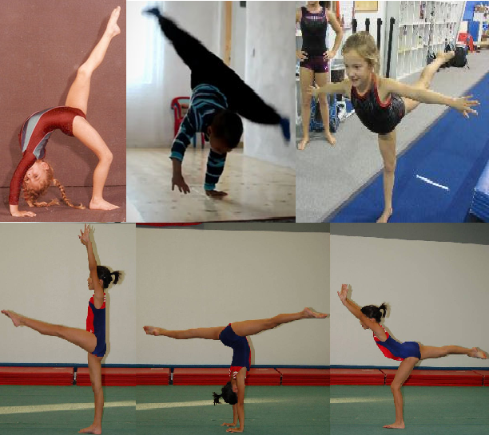

A1. Coaching is love, not a $ .99 ingredient!
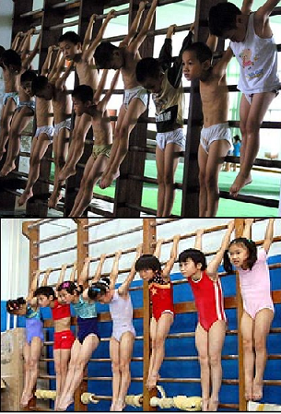
B1: Make a difference!
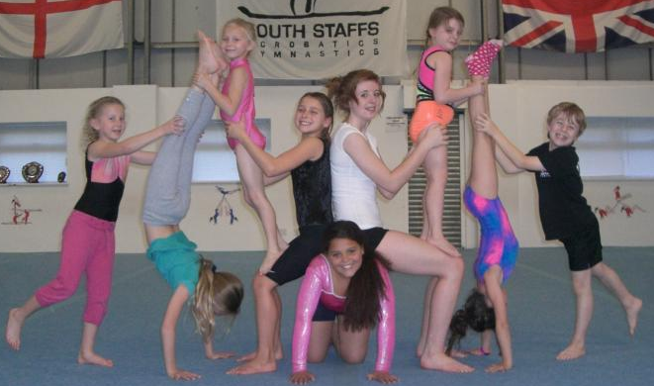.
We are a family in Gymnastics 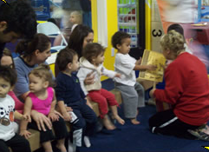
B1. The team!
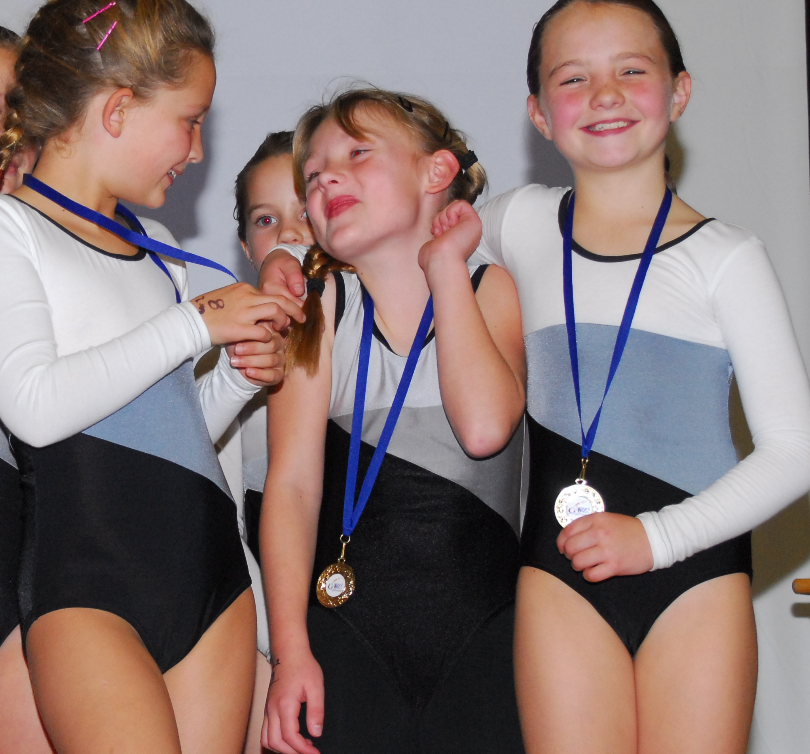
Finally the pink team
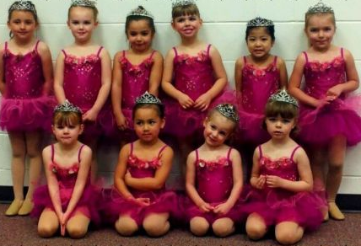
A1. B1. C+ Is not important as long we have fun in a safe manner!.
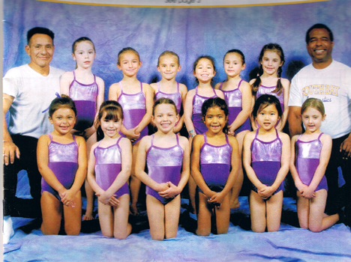

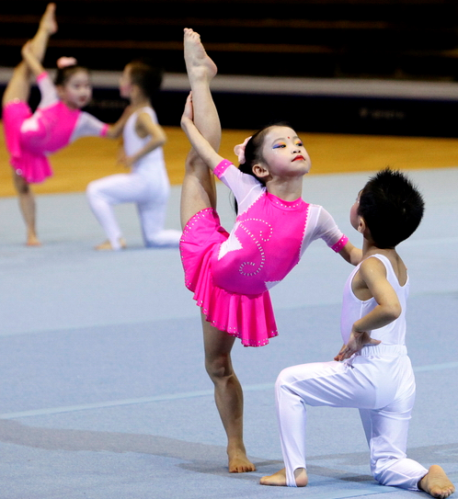
4mygymnast.com
By: Marco and Pintack Gualotuña: This book was created in cooperation with Computers in Education, http://4gymnast.com, acrobatic, artistic, rhythmic, T&T, cheer and ballet media. Edited by Pintack and Marco Gualotuňa. All information on this page and the subsequent pages is copyrighted by Computers in Education; the data may not be copied, not modified, or taken without the express written permission of that party. Images contained herein may or may not be copyrights of the aforementioned company. In the case of shared copyright, no attempt to change these images is implied nor intended to alter them. Any questions should be mailed to m2educate@hotmail.com or 310425-4292.
The best gymnast is a happy one!
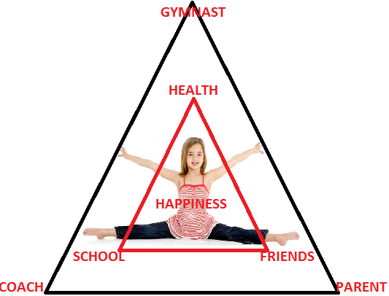
Gymnast events
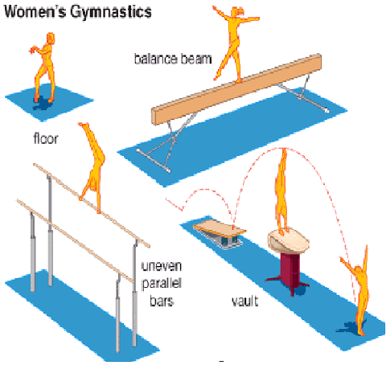
Gymnast in boot camp and pre team advance gymnastics for children 4? 5, 6 years old
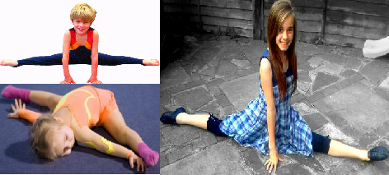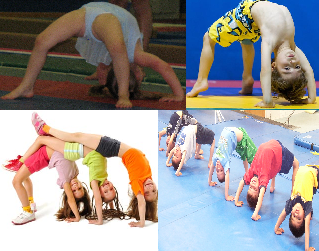
C1. Floor cheese mats safety equipment for advance gymnast or pre team
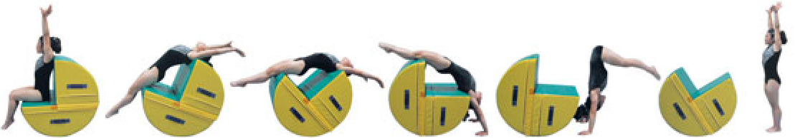

C1. Gymnast simple moves yield difficult skills on the apparatus
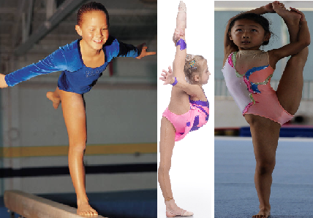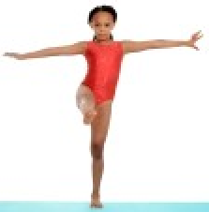
D1. hands stand in the gym, on the floor with my friends
B2. Many hands stand for 8.55
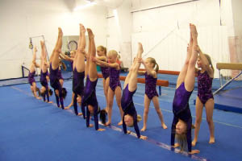
A1. Lunge handstand transition skill 8.1
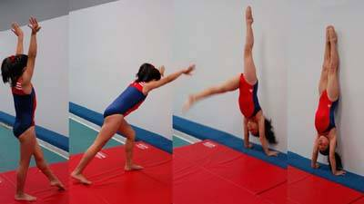
B1. Feet on the wall
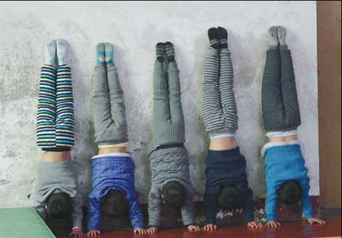
C1. Straddle handstand transition skill 8.2
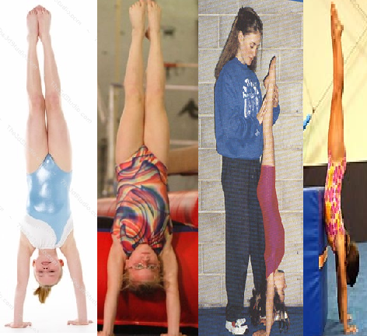

A1. Gymnastics tools for safe
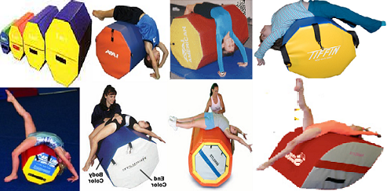
Gymnastics is parents, coach and friends!
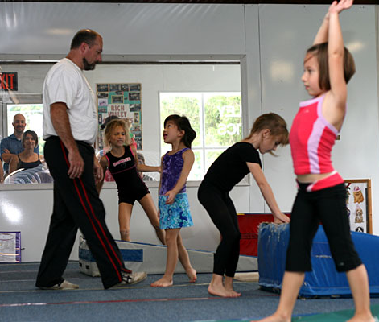

Pirouettes
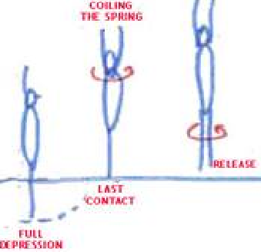
A1. Floor skills done on Beam also!

B1. Equilibrium and balance beam
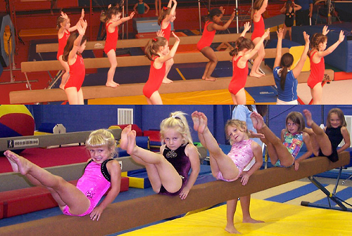
A1. Everyone’s press on the beam perfect skill to promote control
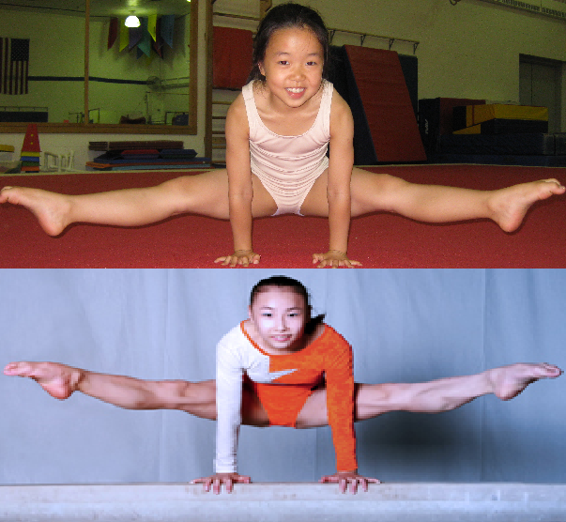

B1. Moves on the floor done on the beam
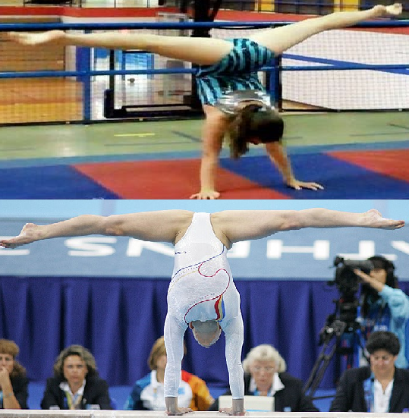
A1. Hands press on the beam advance move
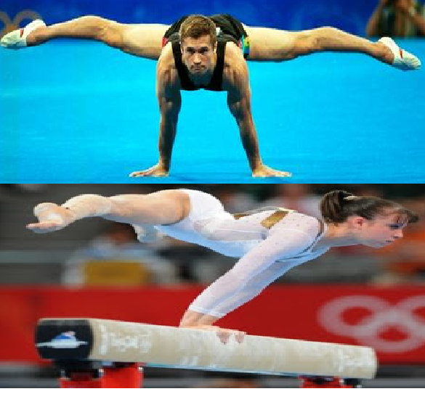

C1. Gymnastics? Every one upside down!
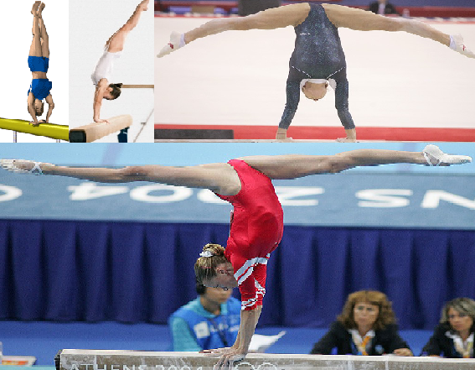
Skills done on the floor are taken to volt, bars, beam, vault, and on the trampoline
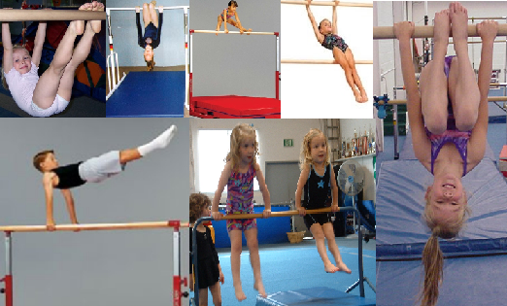

10 | 10 | 10 | 10 | 10 | 10 | NOTES
STRETCHING | CONDITIPONING | BALANCE | MOTION SKILLS | BARS | PARALLELS | Boys 4/5/6
Sitting/pike toes touch butterfly | Set ups | Standing straight tight Heels toes | Squat/ roll | Hands support | Swing/ flight Straddle sits
straddle | Push ups | Scales (3) | cartwheel | swing | Bear walk
tuck | Knee lunge | Straddle (2) | Front dive roll | Cast up | Elephant walk
pike | Kneeling pike | rotation | Back roll pike | Tap swing | Jump off to the side
Hollow/ table top | splits | pike | pirouette | stem | Basket swing
Sequence 4/6 seconds | Holds 6/8 seconds | 4 seconds | 6 seconds | 12 seconds | 10/16 seconds
STRETCHING | CONDITIPONING | FLOOR/BEAM | FLOOR/BEAM | UNEVENBAR | UNEVENBAR | VAULT GIRLS
Sitting pike straddle tuck | Set ups | Standing straight tight Heels toes | Squat/ roll | Hands support | Swing/ flight | Standing straight tight Heels toes
Jump 2 straddle pike tuck | Push ups | Walk coupe passé Développé | forward | swing | Cast/Squat on/jump | Run hurdle 2 squat/pike
Trot skip coupe passé | Knee lunge | Straddle v up squat stand | backwards | Cast up | Clear Hip circle | Straddle/Squat
Lunch hollow | Kneeling pike | Lunge/plie Coupé /passé | Side exit arms around beam | Tap swing/Stem | Shoot through | Running hurdle punch
Table bridge candle stik | Splits straddle | Développé lunge/ Relevé | Jump off tuck 2 squat | Pull over | Stem/Tap swing | Blocking drills 2 straddle
Sequence 4/6 seconds | Holds 6/8 seconds | 4 seconds | 6 seconds | 6 seconds | 10/16 seconds | 5 second
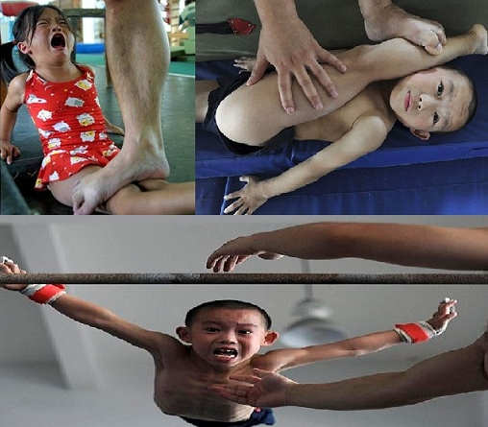
W1. Bad experience a move that scores .00
F1. This is not fun or constructive gymnastics score? What?
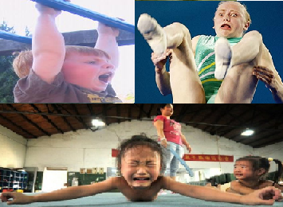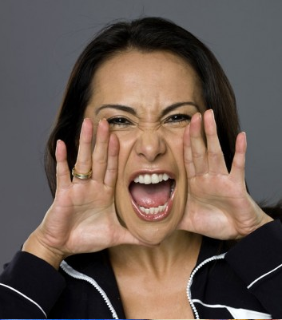

A1. Physics of the Kip!
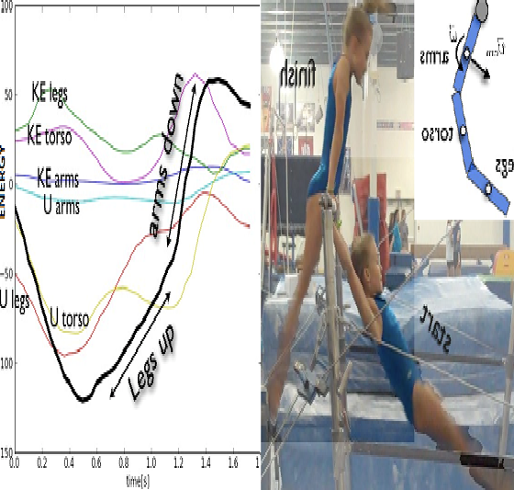C3. Advance coaching techniques 9.
The important point is that the steepest part of the total energy curve is when she is both moving her legs back down and moving her arms down. This brings up a very key point. I had originally assumed (because I really don’t know that much about gymnastics) that this move was mostly in the legs and stomach. Now I think there is a big part in the shoulders. The gymnast really has to have good upper body strength to push her arms down (and increase her center of mass) at the end of this move.

Power
What is the average power this particular gymnast has to produce to make this move? Looking at the graph above, there is a total change in energy of about 176 Joules. This change in energy (and thus the work) takes place in about one second. The power would be:
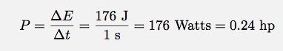
For a 27 kg girl, that is pretty good. Let me just say that you have to be pretty strong to do this move, OR used your body dynamics to perform.

A1: Train all your life for 5 weeks in the Olympics? Just have a good old time!
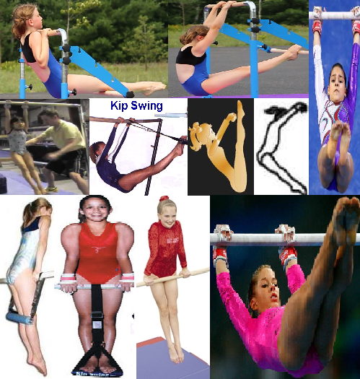
Now that your child wants to join his or her friends in gymnastics, what concerns should you have about injuries? Although children benefit physically, mentally, and socially from participating in this activity, they can develop injuries if they train too hard. Any part of the body can be injured if it is used too much. In gymnastics, the most common overuse injuries involve the shoulders, elbows, wrists, back, and ankles.
In gymnastics, participants must develop flexibility, balance, and strength. The most successful gymnasts are those who are naturally flexible. However, exercising those naturally flexible joints too much, especially the shoulders can make them become too loose. The ligaments, or tissue that holds bones together, can be stretched to the point that they no longer hold the bones in the correct position. For example, if the ligaments in your shoulder are stretched too much, they will not hold the arm in its socket when you move it certain ways. This allows your shoulder to dislocate, or come out of joint (Fig.). Dislocation can lead to serious injuries. To prevent dislocation of any joint, you need to strengthen the muscles surrounding that joint. When the muscles are strong, they will hold the joint together, even if the ligaments are stretched.
Back bends and other activities that cause the spine to curve backward can cause fractures of the spine in young gymnasts (5 to 7 years old). These fractures do not cause problems at that young age and may go unnoticed for years. However, teenagers who remain active in gymnastics may develop back pain because of these earlier fractures. Teenage gymnasts may need bracing or surgery to treat the fractures. A good way to prevent this injury is to not allow children to do deep back bends until they are at least 7 years old.
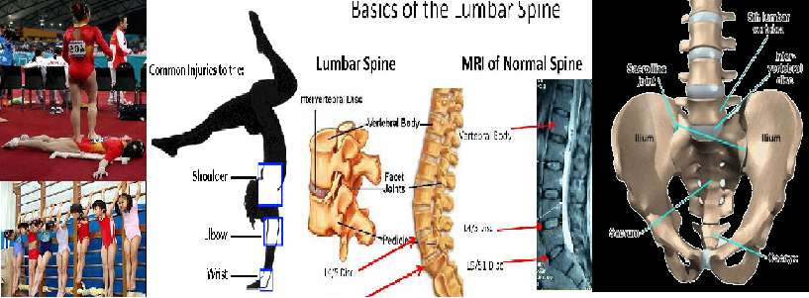
A1. Feet are the most used parts on a gymnast
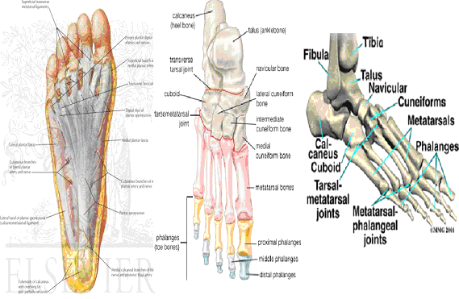
B1. 70% gymnasts are on their feet, 30% on their hands!
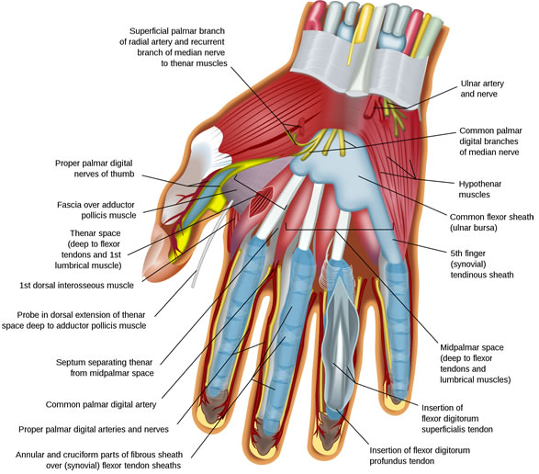
A1. The purple team level 3/4X 5 & 6 years old
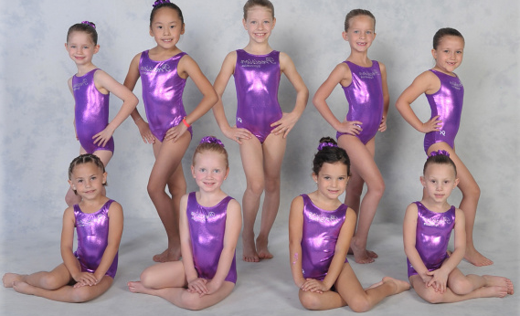
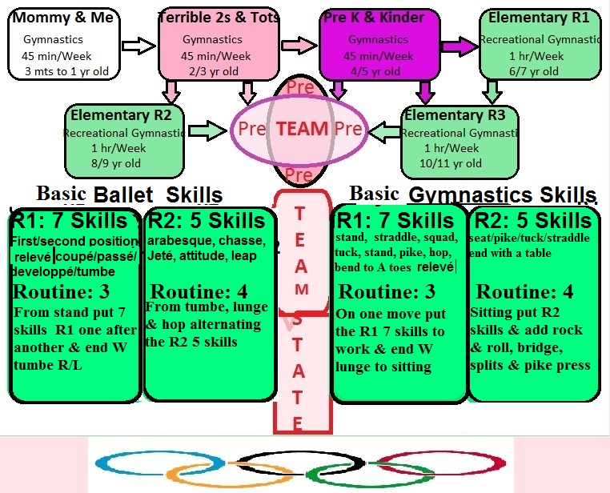
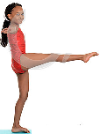 Coupé  Passé Developpé Tumbee relevé 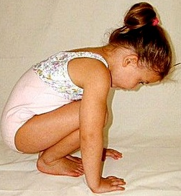Squad straddle splits XCross move up
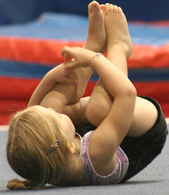 Rock&roll roll F roll B log side roll 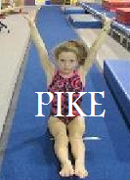 Pike Straddle Tuck table bridge 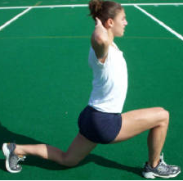Launch: knee Hips Back candle 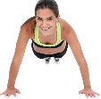Pushup Neck Shoulders Lombard hips 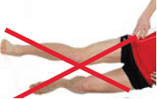Phonation 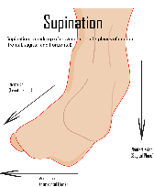Supination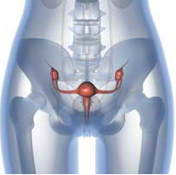 hips  flat feetscale 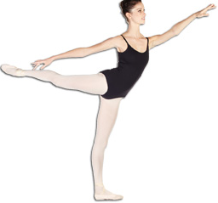arabesque 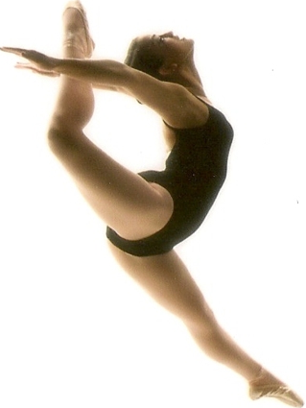leap 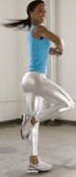 piruette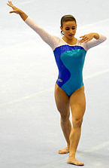 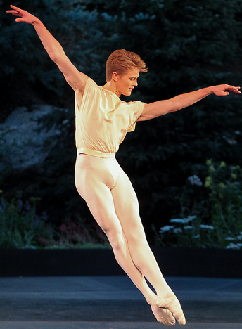chase 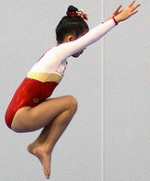 T jump 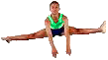S jump 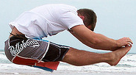 P jump

Coupé/Passé/Developpé/Tumbee/relevé/rabesque lunge handstand
Forward/roll Squad/ Xstraddle/splits lunge cartwheel
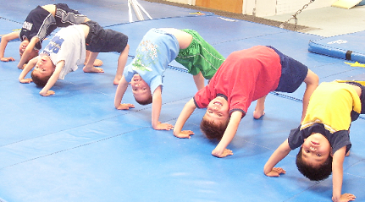Bridge up
 Cartwheel 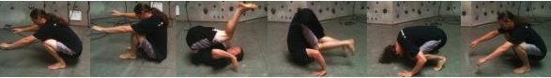 back roll turn 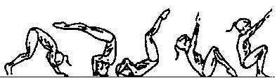dive forwards
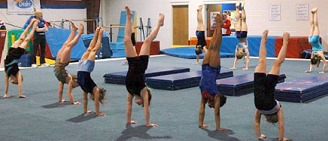 handstands
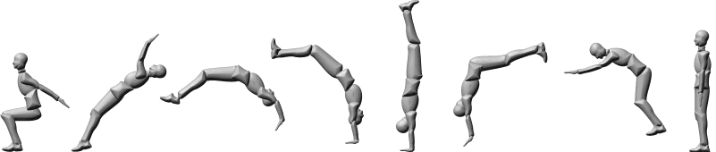flip flap
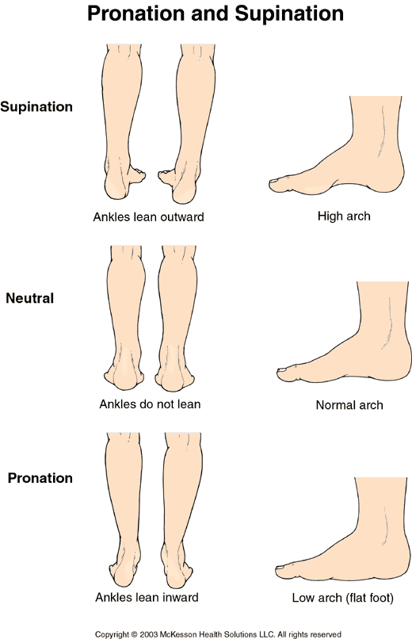

Marco E. Gualotuña
Position: Ballet, Wag, Mag, Wrg, Acro, T&T, MA and Cheer /program developer/director/manager
From one educator to another, I feel is proper and necessary at this time to introduce myself and render my resume for the gymnastics team program developer position. I was a gymnast from the age of 4; I become a ECC gymnast in 75 and the assistant coach in 1976 until 78, this time I went back to school and become a teacher in auto manufacturing. In 1980 left the States and thought El Inca College in South America. 1998 come back to the states and coach at Studio west until 2000 same year become USAG certified Professional coach for women. I went back to Tumbaco-Ecuador and open Gymnastics Academia and run it for 4 years, 2004 begun training the staff of Flairs gymnastics in Florida and in 2005 become part of South Bay Gymnastics until 2009. Went back to school and got my fourth teaching credentials in Career Technical Education or (CTE). Now I am training the staff at 30k tt2 of gymnastics and martial arts center. My experience is Ballet, Wag, Mag, Wrg, Acro, T&T, MA and Cheer. I am licensed to train coaches, trainers and teachers; I write curricular lesson plans for a daily training, clinics and workshops in the latest educational and coaching skills. I have an experience in:
- Community and parent’s integration and evaluation
- Creation of solutions for the teams and recommendations application
- Management in every day operation
- Prepare an assessment; with integration of all variables in the curricular lesson plan with a syllabus to start, pre-post plan implementation and information of the materials needed to instruct the course. Books and magazines applied to the gym
- Implement the safety rules and regulations, at different levels of gymnastics training
- A curricular, progressive skills in gymnastics
- Researches and keeps broad of trends in fields of gymnastics.
- Maintains attendance records for classes and distributes and collects evaluations as requested.
- Assists in arrange competing events.

I write gymnastics curriculums base in a cognitive environment, with biomechanical assessments, tailor to test and prevent injuries and making learning a continuum natural and progressive development element. The curriculum reflexes the programs already in existence in your school’s programs, in simple comprehendible platforms with frames and time tables that are implemented in daily lesson plans. In twenty years of coaching and teaching I learn one simple rule, children and adults learn quickly if teachers, trainers, coaches, facilitators, or parents approach them when they are happy. In all this time I acquired the necessary skills to serve the students better, dear educator, if you need an example of a curriculum, and I can offer you my service an assist you in any manner, I will be delighted. Personally I believed that everyone can learn if given the adequate training. Please browse my site http://4gymnast.com/ for more information. All programs are done on windows platform programs and they are compatible with jack rabbit and QuickBooks accounting programs. All credentials and licenses with reference are available upon request with a proposal and agreement that the curricular example given will not be used with out the proper license.
WARNING: Any activity involving motion or height creates the possibility of accidental injury, paralysis or death. The equipment and instructional materials are intended for use ONLY by properly trained and qualified participants under supervised conditions. Use without proper supervision could be DANGEROUS and should NOT be undertaken or permitted. Before using this manual, KNOW YOUR OWN LIMITATIONS and the limitations of the equipment. If in doubt always consult your instructor. Always inspect equipment for loose fittings or damage and test for stability before each use. We will not be liable for injuries or consequences sustained in the use of the instructional materials, supplies, or equipment sold by us.

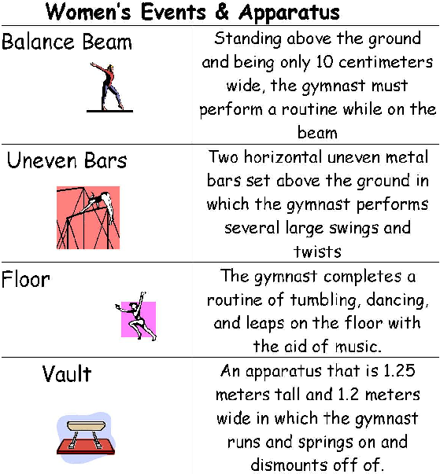

BALLET
F: ___ _ __
S: _____ __
Relieve
C: ___ ___
P: _____ __
D: ___ ____
T: ___ ___
A: _____ __
S: ___ __ __
H: ___ __ __
Name:
WAG
Pike _
Tuck__

Straddle __

Splits
Bridge _

Walk over
Scale__ __
Hand stand

Roll __
Cartwheel

WRG
Pike _
Tuck__

Straddle __

Toe touch

Splits
Bridge _

Walk over
Leap_____
Cartwheel Round off

ACROG
Ballet ___
Wag __
Wrg ____
Cheer __
Pirouette
Routine __
P/T/S:_____
Table:___ _
Bridge:___ _
Press:

CHEER
1: Jump __
2: Pike __
3: Tuck __
4: Straddle
5: Toe touch
6: Base ___
7: Flier _
8: Support
9: Stunt __
0: Routine
Date:
TRAMPOLINE
1: Seat drop
2: Back “ __
3 Front “_ __
4: BHS
5: FH_
6: FT ____
7: BT ___
8: BLOUT
9: FLOUT __
0: Gainer __

Stretch
Seat
Jump up
Press back
Hand stand
Push hands
Pike
Land
Circle
Stand toes

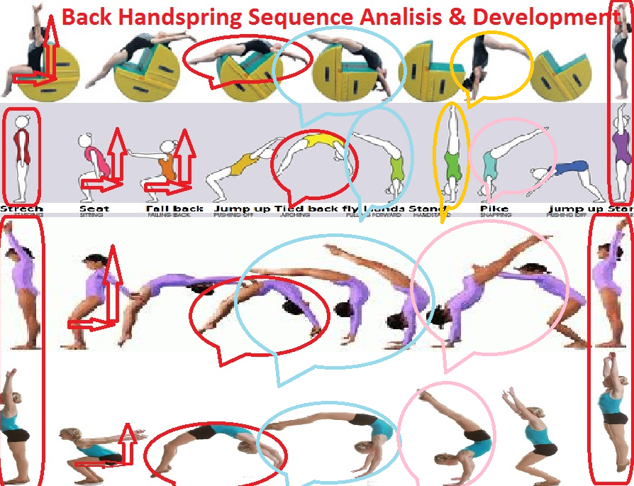

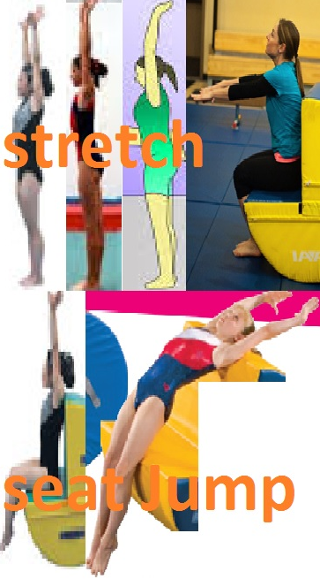
F: ___ _ __
S: _____ __
Relieve
C: ___ ___
P: _____ __
D: ___ ____
T: ___ ___
A: _____ __
S: ___ __ __
H: ___ ____

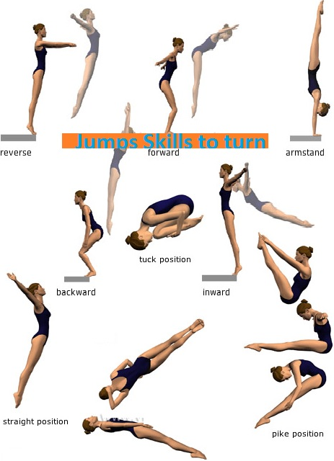

F: ___ _ __
S: _____ __
Relieve
C: ___ ___
P: _____ __
D: ___ ____
T: ___ ___
A: _____ __
S: ___ __ __
H: ___ ____

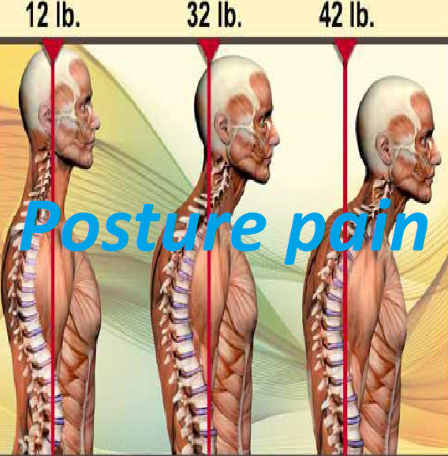
Stretch
Seat
Jump up
Press back
Hand stand
Push hands
Pike
Land
Circle
Stand toes

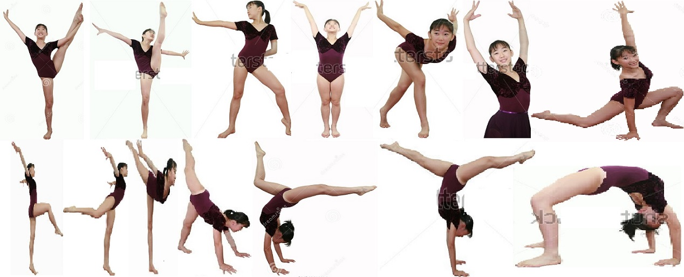

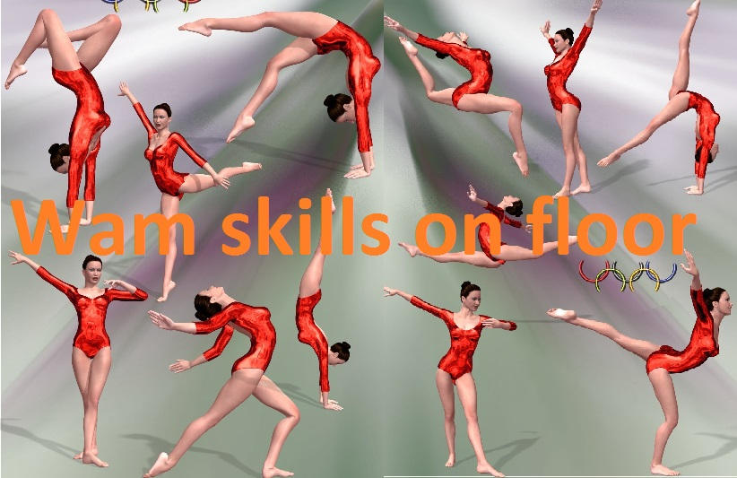
F: ___ _ __
S: _____ __
Pointe
C: ___ ___
P: _____ __
D: ___ ____
T: ___ ___
A: _____ __
S: ___ __ __
R: ___ ____
H: ___ ____
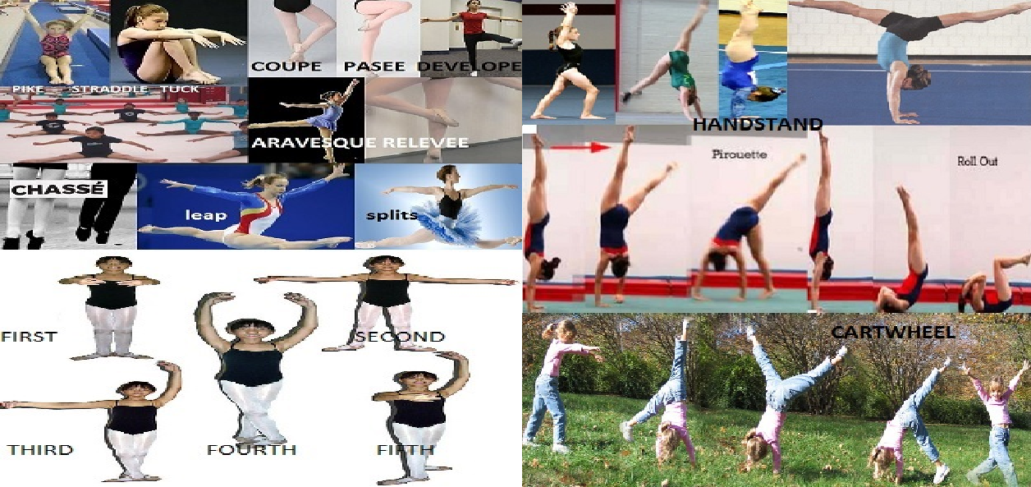
F: ___ _ __
S: _____ __
Pointe
C: ___ ___
P: _____ __
D: ___ ____
T: ___ ___
A: _____ __
S: ___ __ __
R: ___ ____
H: ___ ____
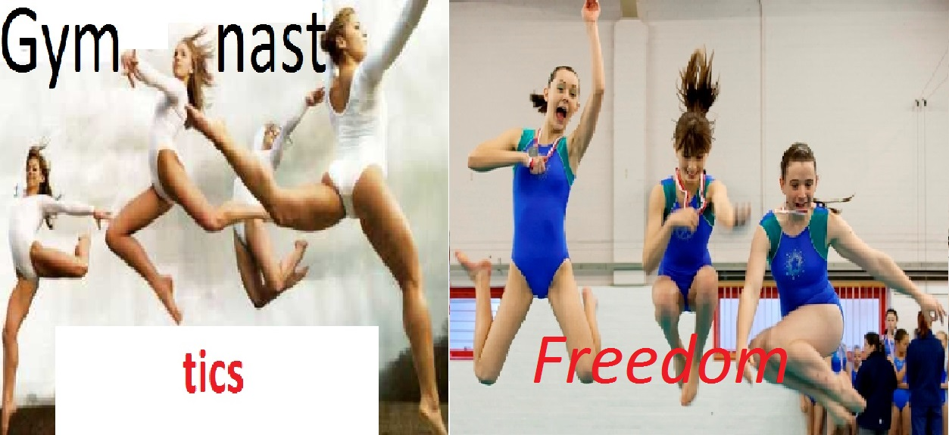
Preschool
Math
Ballet
Relevé
Wag
Aerials
Wrg
Pirouette
Cheer
Liberty



